September 2, 2013 | Volume 88, Number 22
ARTICLES
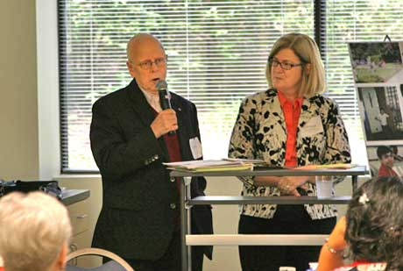
David Dwyer and Christa Blomstrom speak about ministry offered at Our Lady of Mount Carmel, Newport News.

SPRED ministry at OLMC seeks inclusion
by Jennifer Neville
of The Catholic Virginian
Sometimes one feels alone in a parish despite the number of people.
Sometimes a person doesn’t feel welcome at church services.
Sometimes an individual doesn’t fully understand the scripture readings, the homily or the sacraments.
These experiences can be the norm for people with intellectual disabilities. That’s where SPRED comes in.
SPRED, which stands for Special Religious Development, helps persons with intellectual disabilities understand and build their Catholic faith, according to Christa Blomstrom, the director of Christian Formation at Our Lady of Mt. Carmel in Newport News.
Through SPRED, the “friends” (individuals with cognitive disabilities) develop an awareness of God in their lives, Ms. Blomstrom said.
“SPRED creates a sense of belonging and celebrates the gifts that individuals with disabilities bring to the parish,” she said. “The biggest thing it does is show our friends how to have personal relationships with others and with Christ. They have a sense of belonging in their group and their parish.”
Our Lady of Mt. Carmel’s SPRED, which is unique in the Diocese of Richmond, serves adults 19 and older who have cognitive disorders, Ms. Blomstrom said. She is hoping other parishes will host SPRED communities for different divisions: 6-10 years old, 11 to 16, and 17 to 21. That way every person with a disability will have somewhere to go.
When a parish doesn’t have a way to help persons with cognitive disorders explore their faith, the individual may feel “turned away,” said David Dwyer, a lead catechist in one of two SPRED communities at OLMC.
“It’s a tragedy because you don’t just lose that person; you lose the whole family,” Mr. Dwyer said.
Although SPRED began in Chicago in the early 1960s, the program in Newport News didn’t come into fruition until 2011.
In the fall of 2010, several parents approached Ms. Blomstrom and Father Kenneth Wood, then pastor at OLMC, about offering faith formation for people with disabilities.
“These were active parishioners whose children celebrated Mass and social activities within the parish, but they didn’t feel they had a place in Christian formation,” Ms. Blomstrom said. “They really didn’t fit with the typical adult/youth or children’s faith offerings.’
Mr. Dwyer, whose son has a cognitive disability, suggested the parish consider hosting SPRED. He had been involved in the organization in Chicago when his son was an adolescent, and he testified that SPRED could make a difference in the lives of its participants as well as their families.
The program was up and running the following January.
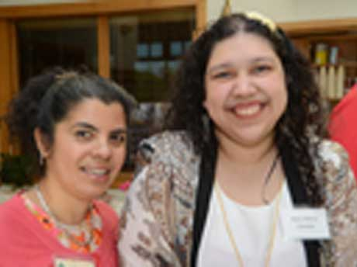
Mary Zamora, right, with her Confirmation sponsor, Veronica Salazar.
Since its implementation, the Our Lady of Mt. Carmel SPRED team has helped 16 friends foster their spirituality, some of whom were from other parishes.
Each SPRED community normally has six friends who are paired one on one with adult catechists who guide them on their spiritual paths, Mr. Dwyer said.
“In many cases, this turns out to be the first adult friend many of them have outside the family,” he said. “This is all about friendships and shared experiences.”
“In addition to the friends’ adult partners, the program offers other volunteer opportunities,” Ms. Blomstrom said. A chairperson develops the SPRED Center and is a liaison between its many members — the pastor, the volunteers, and the friends and their families.
In addition, three leaders for each community plan different components of the sessions — activities to help the friends wind down, worship time, and a simple Agape meal.
Volunteering definitely has its awards,” Ms. Blomstrom said.
“Our friends bless us in so many ways,” she said. “Mentors have said that through their experiences with SPRED, their one-on-one time with their friends has changed them.”
The program runs the school year, and participants return year after year to continue growing as Christians.
A typical session begins with volunteers welcoming the friends to a soothing environment. Soft music, low lighting, comfortable seating and relaxing activities help quiet their souls and prepare for worship.
Seeking to spread the word about the program, the SPRED Center at OLMC will have an open house Saturday, Oct. 12, from 10 a.m. to noon at the church at 100 Harpersville Rd. Anyone interested in the program is encouraged to attend, whether they be catechetical leaders, catechists, or parish advocates in Christian faith formation. These individuals are asked to call 757-595-0385, extension 119, or send an email toleurckml@verizon.net.
“It’s a very inviting atmosphere,” explained Ms. Blomstrom. “Instead of rushing around, SPRED is a time to slow down and be with Christ. It’s a time to help see Christ in one another.”
Participants and their catechists find activities to do together. For example, one friend might paint while another works with clay and still another does a puzzle or arranges flowers. These sensory activities help create a calming tone or centering as they prepare to receive the Word of God, Ms. Blomstrom explained.
Next, the group moves to another setting, “the holy space,” where they respond to scripture readings.
At the close of the session, the participants break bread together in another room. They set tables, complete with a table cloth, linens, and fresh flowers, and then they share a meal.
“They share their stories and celebrate their friendships,” Ms. Blomstrom said.
The group closes its session with a prayer and a familiar song.
Participating in SPRED is often the springboard to integrating persons with cognitive disabilities into the parish at large. This past May, two young adults received their First Communion. Another three friends received the sacrament of Confirmation.
“That was a very special day. It was a combination of a lot of prayers and the fruit of the friendships of our SPRED communities,” Mr. Dwyer said.

